**Practical no.-**06

**Title:** Develop a program to implement frame layout,table and relative layout.

**Roll No.:**15 **Batch-** A **Date of Performance:** 25/01/2024

1. **Table Layout**

<?xml version="1.0" encoding="utf-8"?>  
<LinearLayout xmlns:android="http://schemas.android.com/apk/res/android"  
xmlns:app="http://schemas.android.com/apk/res-auto" xmlns:tools="http://schemas.android.com/tools"  
 android:layout_width="match_parent"  
 android:layout_height="match_parent"  
 tools:context=".MainActivity"  
 android:orientation="vertical">  
 <LinearLayout  
 android:layout_width="match_parent"  
 android:layout_height="wrap_content"  
 android:gravity="center_horizontal"  
 android:orientation="vertical">  
  
 <ImageView  
 android:layout_width="wrap_content"  
 android:layout_height="166dp"  
 android:layout_marginTop="10dp"  
 android:src="@drawable/kkw" />  
  
 <TextView  
 android:layout_width="wrap_content"  
 android:layout_height="91dp"  
 android:layout_marginTop="8dp"  
 android:text="Department of Computer Technology"  
 android:textAlignment="center"  
 android:textColor="#FF0000"  
 android:textSize="25sp"  
 android:textStyle="bold" />  
 </LinearLayout>  
 <TableLayout  
 android:layout_width="match_parent"  
 android:layout_height="wrap_content">  
 <TableRow  
  
 android:id="@+id/firstrow"  
 android:layout_width="wrap_content"

android:layout_height="wrap_content"  
 android:background="@color/green >  
 <TextView  
 android:layout_width="10dp"  
 android:layout_height="wrap_content"  
 android:text="Enrollment No."  
 android:textAlignment="center"  
 android:textColor="@color/black"  
 android:textSize="18dp"  
 android:textStyle="bold"></TextView>  
 <TextView  
 android:layout_width="wrap_content"  
 android:layout_height="wrap_content"  
 android:text="Name"  
 android:textAlignment="center"  
 android:textStyle="bold"  
 android:textColor="@color/black"  
 android:textSize="18dp">  
 </TextView>  
 <TextView  
 android:layout_width="wrap_content"  
 android:layout_height="wrap_content"  
 android:text="Class"  
 android:textAlignment="center"  
 android:textStyle="bold"  
 android:textColor="@color/black"  
 android:textSize="18dp">  
 </TextView>  
  
 <TextView  
 android:layout_width="48dp"  
 android:layout_height="wrap_content"  
 android:text="Percentage"  
 android:textColor="@color/black"  
 android:textSize="18dp"  
 android:textStyle="bold"></TextView>  
 </TableRow>  
 <TableRow  
  
 android:id="@+id/secondrow"  
 android:layout_width="wrap_content"  
 android:layout_height="wrap_content"  
 >  
 <TextView  
 android:layout_width="wrap_content"  
 android:layout_height="wrap_content"  
 android:paddingRight="5dp"  
 android:text="2100780088"  
 android:textColor="@color/black"  
 android:textSize="15dp">  
 </TextView>  
  
  
 <TextView  
 android:layout_width="wrap_content"  
 android:layout_height="wrap_content"  
 android:paddingRight="5dp"  
 android:text="Gade Prasad Vijay"  
 android:textColor="@color/black"  
 android:textSize="15dp">  
 </TextView>  
  
 <TextView  
 android:layout_width="wrap_content"  
 android:layout_height="wrap_content"  
 android:text="TYCM-Lin"  
 android:paddingRight="5dp"  
 android:textAlignment="center"  
 android:textColor="@color/black"  
 android:textSize="15dp">  
 </TextView>  
 <TextView  
 android:layout_width="wrap_content"  
 android:layout_height="wrap_content"  
 android:text="96.00%"  
 android:paddingRight="5dp"  
 android:textColor="@color/black"  
 android:textSize="15dp">  
 </TextView>  
 </TableRow>  
 <TableRow  
  
 android:id="@+id/thirdrow"  
 android:layout_width="wrap_content"  
 android:layout_height="wrap_content"  
 >  
 <TextView  
 android:layout_width="wrap_content"  
 android:layout_height="wrap_content"  
 android:paddingRight="5dp"  
 android:text="2100780079"  
 android:textColor="@color/black"  
 android:textSize="15dp">  
 </TextView>  
  
  
 <TextView  
 android:layout_width="wrap_content"  
 android:layout_height="wrap_content"  
 android:paddingRight="5dp"  
 android:text="Bhadane Aditya Nitin"  
 android:textColor="@color/black"  
 android:textSize="15dp">  
 </TextView>  
  
 <TextView  
 android:layout_width="wrap_content"  
 android:layout_height="wrap_content"  
 android:text="TYCM-Lin"  
 android:paddingRight="5dp"  
 android:textAlignment="center"  
 android:textColor="@color/black"  
 android:textSize="15dp">  
 </TextView>  
 <TextView  
 android:layout_width="wrap_content"  
 android:layout_height="wrap_content"  
 android:text="93.33%"  
 android:paddingRight="5dp"  
 android:textColor="@color/black"  
 android:textSize="15dp">  
 </TextView>  
 </TableRow>  
 <TableRow  
  
 android:id="@+id/forthrow"  
 android:layout_width="wrap_content"  
 android:layout_height="wrap_content"  
 >  
 <TextView  
 android:layout_width="wrap_content"  
 android:layout_height="wrap_content"  
 android:paddingRight="5dp"  
 android:text="2100780086"  
 android:textColor="@color/black"  
 android:textSize="15dp">  
 </TextView>  
  
  
 <TextView  
 android:layout_width="wrap_content"  
 android:layout_height="wrap_content"  
 android:paddingRight="5dp"  
 android:text="Dhakane Aditya Arun"  
 android:textColor="@color/black"  
 android:textSize="15dp">  
 </TextView>  
  
 <TextView  
 android:layout_width="wrap_content"  
 android:layout_height="wrap_content"  
 android:text="TYCM-Lin"  
 android:paddingRight="5dp"  
 android:textAlignment="center"  
 android:textColor="@color/black"  
 android:textSize="15dp">  
 </TextView>  
 <TextView  
 android:layout_width="wrap_content"  
 android:layout_height="wrap_content"

android:text="93.11%"  
 android:paddingRight="5dp"  
 android:textColor="@color/black"  
 android:textSize="15dp">  
 </TextView>  
 </TableRow>  
 </TableLayout>  
</LinearLayout>

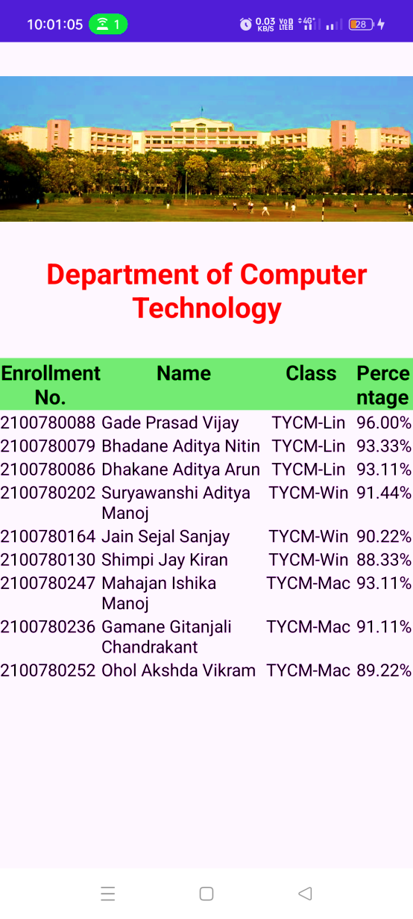

1. **Relative Layout**

<?xml version="1.0" encoding="utf-8"?>

<androidx.constraintlayout.widget.ConstraintLayout xmlns:android="http://schemas.android.com/apk/res/android"

xmlns:app="http://schemas.android.com/apk/res-auto"

xmlns:tools="http://schemas.android.com/tools"

android:layout_width="match_parent"

android:layout_height="match_parent"

tools:context=".MainActivity">

<RelativeLayout

android:layout_width="match_parent"

android:layout_height="match_parent">

<ImageView

android:id="@+id/imageView"

android:layout_width="172dp"

android:layout_height="291dp"

android:layout_centerInParent="true"

app:srcCompat="@drawable/dir" />

<Button

android:layout_width="wrap_content"

android:layout_height="wrap_content"

android:layout_centerVertical="true"

android:layout_marginLeft="5dp"

android:layout_toRightOf="@id/imageView"

android:text="East"></Button>

<Button

android:layout_width="wrap_content"

android:layout_height="wrap_content"

android:layout_centerVertical="true"

android:layout_marginLeft="5dp"

android:layout_toLeftOf="@id/imageView"

android:text="West"></Button>

<Button

android:layout_width="wrap_content"

android:layout_height="wrap_content"

android:layout_below="@id/imageView"

android:layout_centerHorizontal="true"

android:layout_marginLeft="5dp"

android:text="South"

tools:ignore="DuplicateClickableBoundsCheck"></Button>

<Button

android:layout_width="wrap_content"

android:layout_height="wrap_content"

android:layout_centerHorizontal="true"

android:layout_marginLeft="5dp"

android:layout_below="@id/imageView"

android:text="South"></Button>

<Button

android:layout_width="wrap_content"

android:layout_height="wrap_content"

android:layout_centerHorizontal="true"

android:layout_marginLeft="5dp"

android:layout_above="@id/imageView"

android:text="North"></Button>

</RelativeLayout>

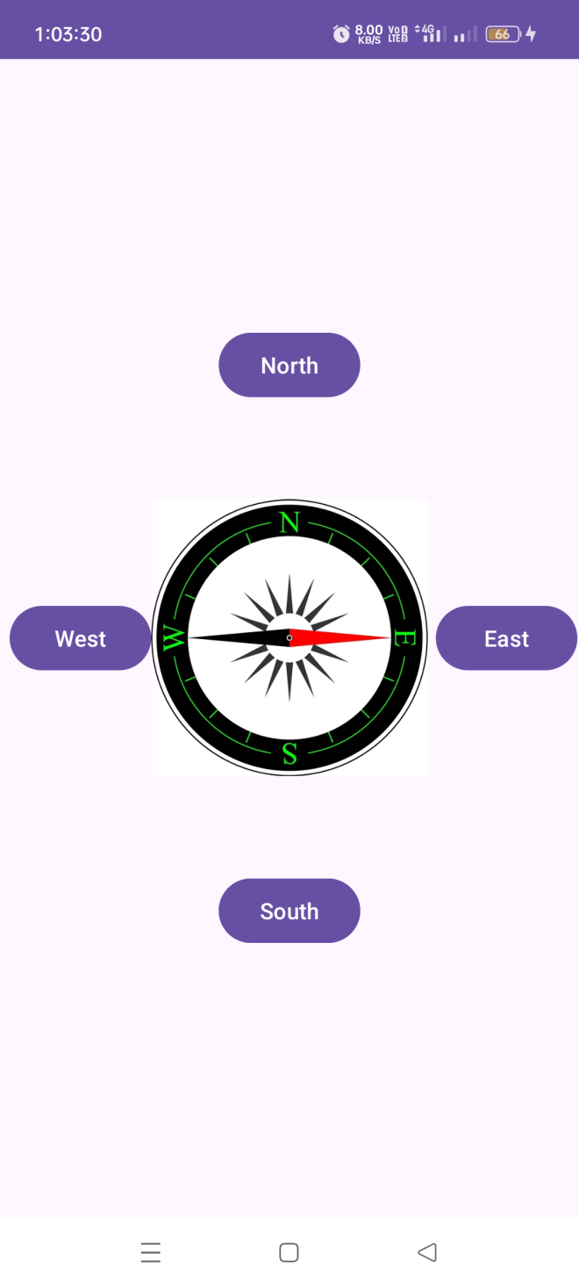</androidx.constraintlayout.widget.ConstraintLayout>